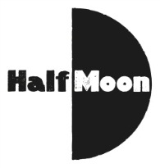
Date: 1 February 2018
Publication: Theare.London
Section: Theatre Guide
URL: https://theatre.london/theatre-guide/top-10-london-shows-for-families-month/

Half Moon and the Half Moon Presents show Glisten, was listed in a “Top 10 London shows for families” article. The full article is on the link above and the Half Moon mention is below.

Top 10 London shows for families this month
From musicals to dance, puppets to drama, we run down the top shows for kids and their parents in February.

Glisten at Half Moon Young People’s Theatre (Nearest tube station: Limehouse DLR) From 22 to 24 February AND Polka Theatre (Nearest tube station: Wimbledon) From 28 February

Age recommendation: 0-18 months old
Glisten (Image: Stephen Beeny)
A sensory experience for the youngest theatregoers, Glisten introduces them to a world of reflective materials and atmospheric music.

