Date: 13 February 2017
Publication: Stage Talk Magazine
URL: http://stagetalkmagazine.com/?p=14671

THE GIRL AND THE GIRAFFE at the 1532 Arts Centre, Bristol
★★★★☆ Mike Whitton 13th February 2017

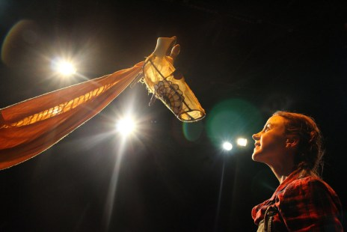
As part of their off-site ‘BEYOND’ season, Tobacco Factory Theatres are showing The Girl And The Giraffe at Bristol Grammar School’s rather splendid new 1532 Performing Arts Centre. This play for youngsters aged three-to-six has been created by Floods of Ink, and is presented by Half Moon, who are London-based specialists in children’s theatre. The Girl And The Giraffe is a tale of how patience and understanding can be the foundation of true friendship. An adventurous young girl is playing in her garden when she suddenly encounters a giraffe. He is uncommunicative and morose, but she is determined to persuade him to join in her play. Why is he so sad? Is he hurt? Does he need a plaster? Or should she bake him a cake? She turns to wise old Granny Owl for advice…
A very clever feature of this production is that all the action is conveyed through the kind of play-activity that any imaginative young child might engage in. For example, the cake-making sequence involves a great deal of ‘pretend’ ingredients. Performers Laurence Alliston-Greiner and Amber-Rose May skilfully use mime, puppetry, simple rhymes and, importantly, moments of stillness to tell their story. They held the attention of today’s sizeable audience throughout the full forty-five minutes of their performance, and there was an eager queue afterwards to ‘meet the giraffe’. It is so very important to ensure that children’s earliest experiences of live theatre are positive. The Girl And The Giraffe certainly succeeds in that regard, and Mums and Dads will be charmed too.

