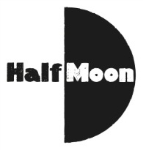
Date: 10 September 2016
Publication: North West End
Section: Reviews
URL: http://www.northwestend.co.uk/index.php/professional-reviews/1329-i-got-superpowers-for-my-birthday-the-roundabout-eccles

I Got Superpowers For My Birthday - The Roundabout, Eccles
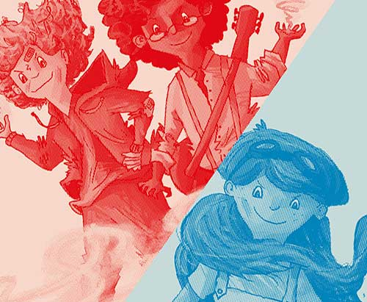
An intimate staging in the round at St Mary’s Park in Eccles was the setting for this production written by Katie Douglas in the Roundabout pop-up Auditorium. This was a joint production from Paines Plough and Half Moon. Prior to the show the actors chat with audience members and practice high fives.

The show starts with all 3 actors in the centre of the auditorium as they wake up on Monday morning each to celebrate their birthday in different ways. The characters Ethan (Richard Corgan), Fiona (Remy Beasley) and William (Andy Rush) captivate the audience from minute one.
The show is played out with no props or scenery just well executed lighting and sound effects. Remy, Andy and Richard/ take all of the parts including narration between.
We follow the 3 classmates as they go through their birthday at school describing the day as they move round the stage as the day moves on. Did they get what they wanted for their 13th Birthday or was it a let-down, the big surprise is the present they get during the evening. Green lighting introduces an unseen Gargoyle in each of the bedrooms as the friends take it on in different ways. Who is the bravest? Certainly not William, but they all get a shock as they manage to defeat the first baddie of the show.

So off to school they go the following morning armed with their newly acquired superpowers. Back to the humdrum of lessons and school in general it’s time to put the superpowers to the test.
Wow what fun they have getting one over on the other kids in the school, however it all ends in a detention for the 3 classmates with superpowers. Detention seems uneventful until the teacher leaves them alone while he goes off to get more marking. We then get to meet 3 more baddies as they come across a Goblin, a Giant Slug and a Dragon. The Dragon takes away the parents of the kids who head off to save them. Can they beat the Dragon or will their parents be lost forever?

The 3 struggle individually to beat the Dragon but soon work out what they need to do and see off the Dragon before hearing a voice calling for them to follow him. This leads to them finding more out about themselves as the show comes to a dramatic ending.

Lighting is provided by Prema Mehta with sound from Dominic Kennedy all held together and wonderful directed by George Perrin.

This production is listed as 7+ however there were a number of under 7’s in the audience who did not appear to be scared at any stage. I asked my 10 year old what he thought of the show and he loved it – he could not pick any part of the show as a best bit saying it was all good, I enjoyed it all.

This is definitely a show to see for kids who may never have experienced the theatre before due to being in the round as regardless of where you sit you have a great view.

Reviewer: Cory Coxon
Reviewed: 10th September 2016
North West End Rating: ★★★★

