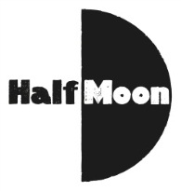
Date: August 2016
Publication: Primary Times
Section: Reviews
URL: http://www.primarytimes.net/edinburgh/page-i-edinburgh-fringe-childrens-shows-/i-got-superpowers-for-my-birthday-childrens-choice-awards-review

I got Superpowers for my birthday Childrens Choice Awards review
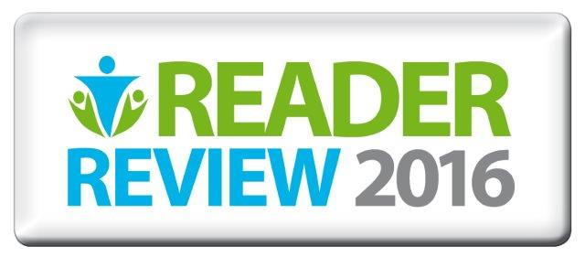
I got Superpowers for my birthday
Fiona, Ethan, and William discover that turning thirteen is no joke when they wake up on their birthday and discover they have superpowers. At first they wonder about the new challenges that face them: Why us? Why now? Maybe it’s just a tummy bug? I Got Superpowers for my Birthday explores the confusion and turmoil of early adolescence. Comparing the challenges of the teen years to the discovery of superpowers is a sweet and sensitive way to discuss the changes and crisis that occur. Adolescence is a time of finding out where you belong and, while each character has reasons to feel alone, they each realize how much they have to offer the world. This high energy and fast paced show reminds the audience that even the most unfair things are best fought as a team. Watch the three teenagers as they learn to destroy their enemies (including Barbara the Slug) with their newfound abilities. Older kids and young teenagers will especially enjoy this fun show.
Our young reviewers said:
"lots of lights and sounds" - Thomas (4) "I really liked the monsters, they were funny" - Calum (7)

