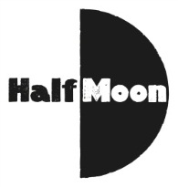
Date: 14 August 2016
Publication: Reviews Hub
Section: Reviews
URL: http://www.thereviewshub.com/i-got-superpowers-for-my-birthday-summerhall-edinburgh/

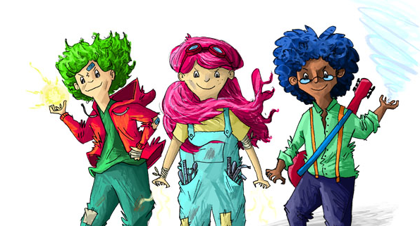

I Got Superpowers For My Birthday– Summerhall, Edinburgh
Posted by: The Reviews Hub - Scotland in Drama, Edinburgh Festival Fringe, Edinburgh Fringe 2016, Family, Review, Scotland14/08/2016 0

Writer: Katie Douglas
Director: George Perrin
Reviewer: David Doyle

It’s not easy being a teenager. Parents, school, and friends all make things more difficult, particularly when you’re throwing the best birthday party ever. So then just what would happen if on your thirteenth birthday you woke up and suddenly had superpowers? That’s what Fiona, William, and Ethan have to contend with in this exciting and lively production from Paines Plough and Half Moon.

When they wake up with the ability to cause earthquakes, shoot fire from their hands, and to freeze things with a look, the young trio has to navigate a world in which they have to keep their powers secret. Eager to right the wrongs done to them, they initially have some fun at the expense of others before finally having to put their powers to the test when a birthday party in the local community centre takes an unexpected turn.

The script from Katie Douglas is engaging and action packed from the first moments, offering both laugh-out-loud humour as well as an important life lesson for young audience members. The show boasts excellent performances by Remy Beasley, Richard Corgan, and Andy Rush under the inventive direction of George Perrin, who makes the most of the in the round setting. Prema Mehta’s lighting design throughout is exemplary, often acting as a fourth character and helping to bring the whole piece to life.
This is a superhero story like no other. Fast-paced performances, some really slick design, and a cracking script make for a wonderful piece of theatre. Inventive storytelling is enough to keep adults happy while a magical story is enough to ensure children of all ages will be captivated from the opening to the closing moments of the show.

Runs until 21 August 2016 (not 16) | Image: Amberin

