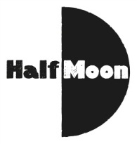
Date: 7 August 2016
Publication: Theatre and Tea
URL: https://theatreandtea.com/2016/08/07/e-is-for-earth-fire-and-water/

E is for Earth, Fire and Water
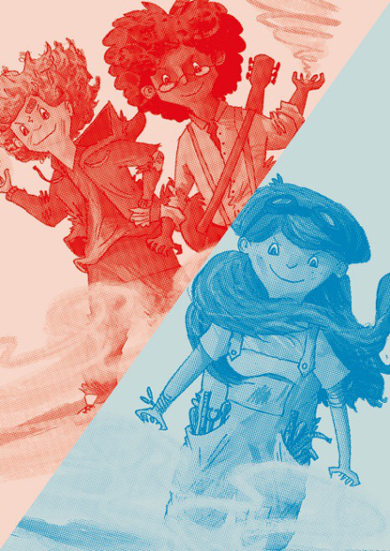
Paines Plough have got a storming line up at the Roundabout at Summerhall this year and their slice of fun for children is no exception. I got superpowers for my birthday is a collaboration between Half Moon Theatre and Paines Plough, and transforms the space in to a battleground for monsters and an arena of superpowers as three school children get a little more than they bargained for on their thirteenth birthday.
Ethan, Fiona and William are not friends in school, in fact they couldn’t be more different, but they all have the same birthday. As each of them becomes a teenager, something strange happens and they gain superpowers – Fiona suddenly has fire coming out of her fingertips, Ethan can make the earth shake and William can use water and ice to his advantage.
As the three fight off unwanted guests including Babs the humongous slug, gargoyles and a dragon with an appetite, they soon come to realise that if they join forces, something incredible might just happen. The Roundabout is brought to life with things that go bump in the night and it is down to our three heroes to protect not only the biggest party of the century, but life on Earth as we know it.
As one little girl cowered in the front row as the Darkness was unleashed and others wooped and high fived during victory dances, this earth-saving quest makes for a heart warming and exciting adventure. A brilliant production from start to finish as the direction lifts the three superheroes and the monsters off the page fantastically.
I got superpowers for my birthday | Roundabout @ Summerhall | 11:00

