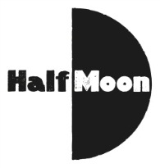
Date: 8 August 2016
Publication: edinburghfestivalsforkids
URL: https://edinburghfestivalsforkids.com/i-got-superpowers-for-my-birthday/

I Got Superpowers For My Birthday was mentioned in The Telegraph’s 50 best shows to see at the 2016 Edinburgh Festival and Fringe. Full article can be seen at the link above. The show’s mention is below:

I Got Superpowers For My Birthday

An evil overlord plans to turn the world to ice, but thankfully three preteens have just been given their very own superpowers and are ready for adventure.

Roundabout @ Summerhall (0131 560 1581) Aug 5-21 (not 9, 16), 11am (Ages 7+)

