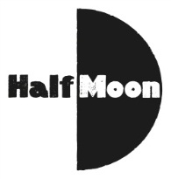
Date: August 2016
Publication: The Skinny
Section: Theatre
URL: http://www.theskinny.co.uk/festivals/edinburgh-fringe/theatre/paines-plough-2016-interview

