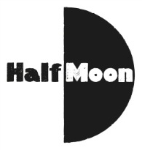
Date: 21 April 2106
Publication: Children’s Theatre Reviews
URL: https://childrenstheatrereviews.com/2016/04/21/the-girl-the-giraffe/
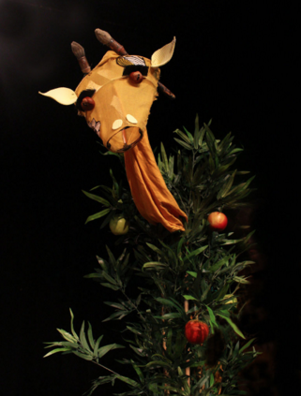

THE GIRL & THE GIRAFFE
April 21, 2016 · by flossiewaite · in April 2016. ·
Review by Flossie Waite
Half Moon presents a Floods of Ink production
Reviewed at Half Moon Theatre
Touring nationally until October 2016
For ages 3-6

The latest production from Floods of Ink follows one girl’s attempts to befriend the unhappy giraffe that lives at the bottom of her garden. It’s the second show I’ve reviewed this year to tackle depression. The Girl & The Giraffe and Intrepid Ensemble’s Jellyfish are different in lots of ways, but identical in one: there’s an incongruous moment when one of the characters explains (using the cover of metaphor) what mental illness is. The speech’s length and the instructive tone stick out, and it feels detached from the character speaking – though describing his own experiences, for instance, Giraffe suddenly speaks in the third person. This is ‘the message’, the medicine barely hidden in the ice-cream. It leaves me a bit puzzled – both companies think that children’s theatre is a good medium for exploring these issues, so why then lose confidence in its power to subtly convey serious themes?

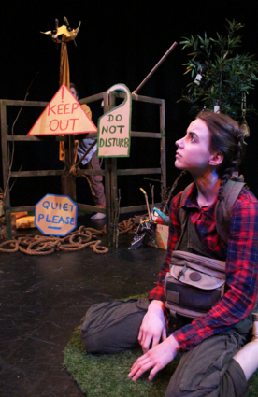
Maybe it’s to do with expectation. A play for adults dealing with similar ideas can reasonably assume its audience will have prior knowledge of the topic, whereas a piece like The Girl & the Giraffe is probably introducing new concepts to the young people watching. Adults are likely to have encountered other fictional work on the same subject, so there’s a freedom to simply offer one more voice, one additional slither of experience, to join a plethora of viewpoints. Should theatre for young audiences be more like that, rather than bow to the pressure to achieve everything in 50 minutes – explain and explore and present a ‘complete’ experience?

Floods of Ink is limited by its preoccupation with what the audience will take away. At times the action feels like the means to an educational end, one that is constantly circling it’s central theme of mental illness. The play feels like a bird with its wings clipped – just when it begins to fly, it returns to previous ideas, repeating them for emphasis whether they bear repeating or not. Like Girl’s cake, which she makes throughout the show – mixing up ingredients made of household items is an entertaining, noisy scene once, but as it becomes a vehicle for Girl and Giraffe’s relationship to develop, the fun gradually wears thin. The Giraffe and the Girl lacks the imaginative freedom and depth of their previous show Up In The Attic.

With his downcast eyes, lumbering head and sulky, deep voice, Giraffe reminds me of another dejected animal: Eeyore. Though never plainly stated, it’s clear that the melancholic donkey struggles with his mental health. Winnie the Pooh, Piglet and the gang accept him just as he is, give him the space that he needs, and are there for him whenever he wants. Through their story of friendship, readers and viewers unwittingly pick up a lot: The Girl and the Giraffe should treat any lessons learned as incidental, and focus on the central relationship.

I wrote that Jellyfish should stop worrying whether the young people watching understand explicitly that it’s “about mental illness”, and I feel that applies here too. A good piece of theatre asks more questions than it answers: if an audience are allowed to draw their own conclusions, they will carry on thinking about it far longer, rather than ticking it off in their mind and leaving it at the theatre.

