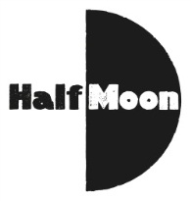
Date: 19 April 2016
Publication: Live Theatre UK
URL: http://livetheatreuk.co.uk/2016/04/19/the-girl-and-the-giraffe/

The Girl And The Giraffe
Half Moon Theatre
By Christine Firkin
April 19, 2016
****
Dear the best giraffe in the world, pleeeaaaassseeee come out to play. p.s it won’t be the same on my own.
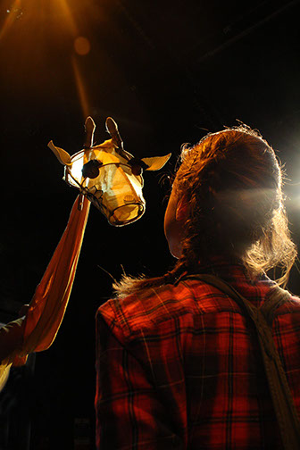
The Girl and the Giraffe is a play for children from the company Floods of Ink and was presented at Half Moon Theatre as part of a current tour. It was created in collaboration with director Titania Krimpas, designer Amy Yardley and composer Greg Hall and is aimed at a very young audience. At the performance I saw, there were 3 year olds with their parents and two classes of Year 2 children from a local primary school.
In an age where children are bombarded with electronic media that can be harsh with its fast pace, loud music and overly bright colours, this play is a peaceful haven. The first section is without speech as Girl, played by Amber-Rose May, enters a space reminiscent of a suburban garden with play tents made from sheets and furnished with treasure boxes and buckets. The design by Yardley has given the actors and audiences a plethora of detail to enjoy as objects are selected to transform to anything one desires.
Happily creating her own fun, Girl is drawn to invite a nearby giraffe to come out and play. The giraffe is a cleverly crafted puppet…nothing more than a bag at the end of a stick with paint brushes attached to make the familiar silhouette of the ossicones on top of the long-snouted head. The body is yellow material wrapped round the arm of actor Laurence Alliston-Greiner who manipulates the puppet so well that in no time at all the handler is forgotten behind the character of the woebegone Giraffe. He patently and emphatically doesn’t want to come out and play.
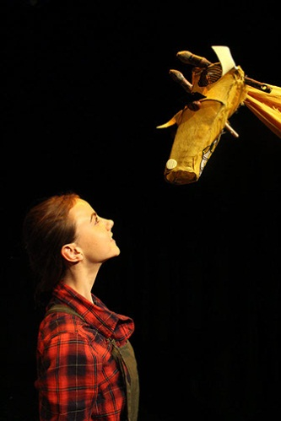
The giraffe is clearly in some form of depressive state and resists several attempts by Girl to draw him out. Eventually Girl consults the oracle Owl for advice. Owl is a second puppet character for Alliston-Greiner and, like Giraffe, is little more than a face on a stick and a body of cloth. Simple but magical.
Fortunately the perseverance of Girl is rewarded and she and Giraffe spend the rest of the play making a ‘cake’ and generally indulging in what has been called over the years playing pretends.
The direction of Krimpas has clearly defined the piece and the action flows nicely along its gently meandering path towards a satisfying ending of peace and friendship. The light theme underneath the action, mental health and its exploration for young children, is well served within the play.
Supporting the magic of imaginative play is an original musical score by Greg Hall. It’s gentle and whimsical and provides a cloud of sound that embraces the action of the play.
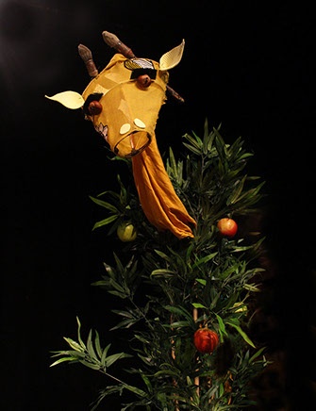
May and Alliston-Greiner concoct a world of light and charm that calls to its young audience to come along with them for the ride. It’s surprising that the young audience doesn’t actually get up and join Giraffe and Girl as they bake and play and look at the stars.
It is the reaction of the children in the audience that is the true mark of the success of The Girl and the Giraffe. This is entertainment that demands an engagement of the audience at a much deeper level than that required to watch a cartoon. At this performance very little noise was made as little bodies leaned forward to catch every sound and see it all. On the way out of the theatre they all rushed to say goodbye as they happily clambered out of the magical space created for them.

