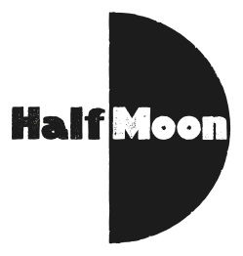
Date: 5 October 2015
Publication: This Week London
Section: London With Kids - Top Ten - October Half Term
URL: http://thisweeklondon.com/article/three-to-see-on-12-oct-the-cherry-orchard-a-wolf-in-snakeskin-shoes-map-of-me/?utm_content=buffer22101&utm_medium=social&utm_source=twitter.com&utm_campaign=buffer

Three To See on 12 Oct: The Cherry Orchard, A Wolf In Snakeskin Shoes, Map Of Me

The Cherry Orchard | Conway Hall | 12 October
One performance only, courtesy of The Conway Collective, of what’s described as a unique performance of the Chekhov classic, specially re-imagined for Conway Hall; it has a huge cast, promises to completely transform the venue, and it sounds like the audience will be getting involved too. See this page here for more info and tickets.

A Wolf In Snakeskin Shoes | Tricycle Theatre | 8 Oct-14 Nov (pictured)
Ah, ‘Tartuffe’. Back in the day, I could understand this French play. Now my command of the language is a little rusty. So it’s a good thing that ‘A Wolf In Snakeskin Shoes’, a fresh take on Moliere’s classic, is in English. Created by award winning playwright Marcus Gardley, it moves the action to a world of fast food tycoons and megachurches, and involves a big glut of talent; familiar TV and West End faces Sharon D Taylor and Lucian Msamati are in the cast, and it’s directed by Tricycle’s acclaimed artistic director Indhu Rubasingham. See the venue website here for more info and tickets.

Map Of Me | Half Moon Young People’s Theatre | 12-17 Oct
This looks like a timely piece for teenagers to absorb, focusing as it does on an emotional story of migration, telling the tale of a young girl fleeing war in her home country. Exploring the effect that such displacement can have on children, it’s based on the real life stories of young asylum seekers, and features the considerable talents of Azfa Awad and Rosemary Harris. More info and tickets here.

