Date: 17 December 2016
Publication: Children’s Theatre Reviews
URL: https://childrenstheatrereviews.com/2016/12/17/people-are-people/

PEOPLE ARE PEOPLE
December 17, 2016 · by flossiewaite · in December 2016, Reviews. ·
Reviewed by Charlotte Fleming
Half Moon Presents a Floods of Ink production
Reviewed at Half Moon Theatre
Touring nationally from December 2016
For ages 13+

People are People demonstrates that when you approach a young audience sincerely and honestly, the result is more than educational, it is art. What this production remembers more than any I have seen, is that teenagers are people.

The two performers sat with us after this hour long production for a very welcome Q&A. It is a show which invites reflection and conversation, and the cast of Floods of Ink were wise to make time at the end of the performance to offer this opportunity. Their concept, they told us, had always been ‘gender’ and grew from this, however the ‘message’ they say, was something which they allowed to come out organically from months of research, conversation and, as is clear from the end product, careful thought.

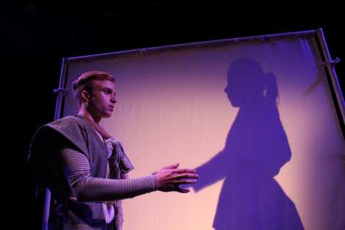

Their approach paid off, with a production which gently develops ideas in layers, one upon another. The premise is relatively simple: a cold Siri-like computerised voice welcomes us to a white-walled institution, the ‘normalisation centre’, designed to help the genderless character define their ‘identity’. There is reference to a ‘social online census’ which collects personal data, and although we might think we are sitting in a futuristic dystopia, perhaps we are just reminded that every online form, social media profile and application requires us to select a box to define us: male or female.

Performers Amber-Rose May and Laurence Alliston Greiner share the central role, a 19-year-old who is both and neither male or female, but who is asked to ‘pick one’. Undertaking tasks designed to help them with the choice, they begin, as we all do, with play. Amber-Rose is given gendered toys, but although elegant in satin ballet shoes, and athletic in leather boxing gloves, our hero is torn between these two roles, twisted into uncomfortable shapes.

Continuing to insist on a decision, the disembodied voice lists a selection of 200 gender types to choose from, only to be replaced by a short history of the ambisexual narrative. Shadow puppets describe Indonesian immortals who were more than black and white, while Greek gods emerge from behind masks of tradition to explore the myth of gender.

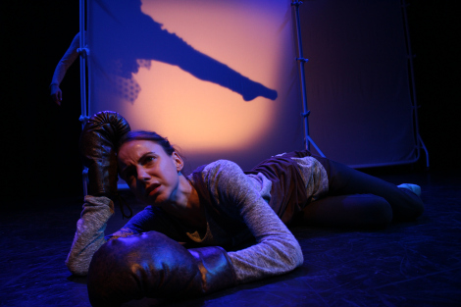

Our hero grows in confidence against this supposedly androgynous but ultimately constructed ‘helpful female’ tyrant, declaring that they ‘choose to change’, demanding their right to be recognised and finally deciding not to choose. And so the final layer is delivered by the cool voice of the computer: without this information the system cannot protect you within your sphere. The Equalities act of 2010 protecting citizens from discrimination on the grounds of race, religion, gender and sexuality, requires the person to be defined as a specific gender, in order to be said to be discriminated because of it. The character is not obligated to choose, but in refraining from doing so must absent themselves from the protection of society.

The audiences of young people who (should) come to see this show will not be totally unfamiliar with the concepts it addressed. Celebrities, television programs and social media have raised the profile of people of different genders and sexualities, and in particular the trans community. Perhaps with this, and certainly with their own cis-gendered identities, in mind, Floods of Ink decided to focus on fluidity, rather than speaking through a specific ‘named’ gender. The person we come to understand as every young person, struggling to explore their identity, their choices and their society, is frustrated by limited options, and so the final triumph of this piece is that it does not condemn its audience to the same fate.

The cast described the varied reactions from young audiences: leaning forward, eager and engaged, or surprised, looking to one another for confirmation, happy to offer comments and questions afterwards. Some questions came up more than once, including a challenge to the creators who chose to make the computerised voice ‘female’ sounding, demonstrating how the show’s simplicity trusts its audience with subtle approaches, and to make intelligent connections.

The concept of gender is in itself very nuanced and, as the play shows, open to interpretation, change and growth. People are People doesn’t feel like a lesson. This is art, not school. It lays out the humanity of the issue and allows its audience to enter into the problem, not as children, as people.

Charlotte Fleming is a blogger, proofreader and editor, and Managing Director of I Read Your Writing. Charlotte is cisgender female and writes from her experience as such, but would welcome comments from anyone else who have seen the show. Follow Charlotte at @ReadYourWriting

