Date: 22 March 2017
Publication: Live Theatre UK
Section: Reviews
URL: http://livetheatreuk.co.uk/2017/03/22/review-boys-dont/

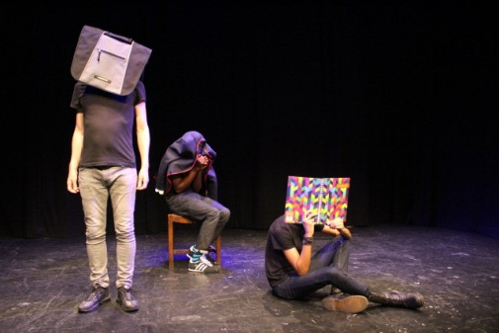
Review – Boys Don’t
By Madhia Hussain

Performing in front of an audience of children, the team behind Boy’s Don’t integrate feminism into a fifty minute piece on boys in contemporary society. Three separate tales depict isolated incidents in which early experiences contradict the patriarchal idea of masculinity. Boy’s Don’t differs from other plays by using spoken word to engage with its young audience. By keeping it short, it is able to connect avoiding clichéd repetition.

Opening this performance piece with “Boys were raised on deserts & fables, and instructions that men must and boy’s don’t…” leads into Rosemary Harris’ play targeted at children aged between 8-12. One school group fill the auditorium at Half Moon Theatre and this diverse London school class pay close attention.

Hadiru Mahdi delivers story one: Abdul’s younger protégée admires him. Wanting to hang with the older boys, he aims to impress whilst building his own reputation. His actions soon spur into violence and a mother’s son, is left hurt and disappointed.
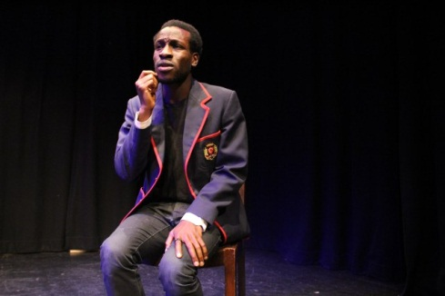
Sonny Curtis’ lyrics: “I fought the law and the law won” resonate with conflict between police and young black men. A few words and the graphic imagery behind those lyrics drastically form a possible outcome that send chills into the auditorium. Mahdi, by tugging his hoodie, fits into the depiction of a young black boy and, performing in front of an ethnically diverse audience, his words have the power to reach those who often feel alienated from the arts scene.

Author Steve Tasane delivers story two: Tyler is wearing the wrong trainers. His cardboard trainers bring poverty and also homelessness to the imagination, insinuating much more than bullying.

A school toilet is Tyler’s place of sanctuary; somewhere he can hide and cry. That is until technology adds to his misery and soon spreads it to every inch of his existence. What is portrayed, instead of a harrowing end, is Tyler’s optimistic message to express one’s feelings.
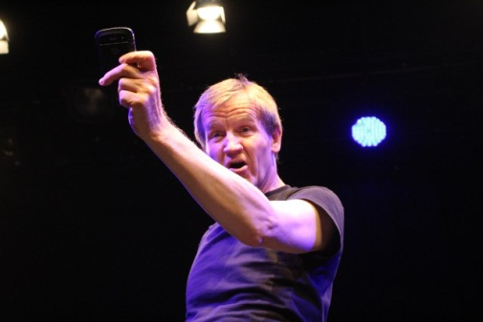
Story three is delivered by Justin Coe who is boo-hooing and questioning his own sorrow. Descending from a line of masculine ancestors, it is ingrained in his existence that crying is not a man’s privilege. Looking back through history, we come across each father, whether it’s a war veteran, or a great ancestor killed by a horse, each man faces their own problem, following the mantra that boys don’t cry and he bets that not one of those cried. In the present moment a grandad losing his wife, at last, generations later, normalises this human emotion.

Papertale’s devised piece concludes the production by returning to folktale imagery of the desert and fables, allowing the audience to question its meaning. Harris takes stage and engages with the audience leading to genuine surprise in witnessing many raised hands. Not only questioning the topic yet seeking answers to the creative process behind Boy’s Don’t.

A vital question asked by a girl in the front row: “is boys crying in a public place still a problem?” Upon looking around the room seeing this young group disagreeing raises a vital question (or more so a point): social stigma is what adults are teaching, therefore who should be the target audience here?

