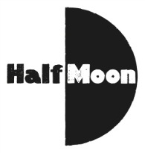
Date: 19 March 2017
Publication: Go To A Show
URL: https://gotoashow.wordpress.com/2017/03/19/boys-dont/

Boys Don’t….
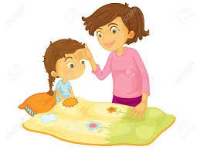
Posted on March 19, 2017 by gotoashow
Hello lovely readers
Today, I’m afraid, is going to be a shorter than normal blog because I haven’t been well this week. Nothing serious, but serious enough that I had to miss my drama lesson which is UNHEARD OF. Thankfully I seem to be on the mend but because I haven’t really been feeling myself, I’m giving myself a bit of a break this week.
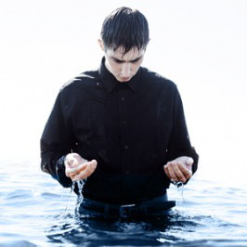
Having said that, I would like to tell you about a show that I was very kindly invited to see and review. Sadly I can’t make it this time as it’s a bit far away and my mum and dad can’t get me there on time because of their work. But the show looks amazing and I would really recommend that you look it up and give it a try if you can. It’s called “Boys Don’t” and it’s at the Half Moon theatre in East London. It’s a show all about what happens when boys show their feelings. I think this is a really interesting subject because we are often taught that boys are big and brave and strong and that they don’t cry. I suppose I never really thought about this much before but actually, when you think about it, boys must feel sad sometimes, and scared too. So what are they supposed to do when that happens? It’s a bit easier for girls because it’s not usually seen as being a bad thing if we cry when we are sad or scared. You might have heard someone say to a boy “stop crying like a girl” like a boy crying is a bad thing. In fact we had an assembly about this at school, although we were talking about how girls are as good as boys. For example, don’t “run like a girl” suggests that if you run like a girl you must be bad at running when actually girls can run just as well as boys. I think it’s about time people realised that we are all humans and it doesn’t matter if we are boys or girls, we all have thoughts and feelings and strengths and weaknesses and what is wrong with that?
So I’m really sorry that I won’t be able to see Boys Don’t but if you can you can buy tickets here:
https://www.halfmoon.org.uk/book/

Thank you so much Stephen Beeny for inviting me and I’m really sorry that I can’t make it this time. I hope it’s a great success though and I am sure it will be!
Have a great week everybody.
Love Ariella xxx

