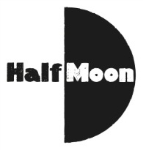
Date: 1 December 2016
Publication: Londonist
Section: Education
URL: http://londonist.com/things-to-do-in-london-this-weekend

Big Wow Small Wonder was mentioned in the Londonist feature, Things To Do In London This Weekend: 3-4 December 2016. The full article can be found at the link above, but our entry is below.

Saturday 3 December
Big Wow Small Wonder at Half Moon Theatre
BIG WOW SMALL WONDER: Perfect for any child tired of feeling little, Big Wow Small Wonder follows the story of Justin, the smallest boy in the whole town. It's at the Half Moon Theatre in Limehouse and is performed by poet Justin Coe, ideal for children aged 4-9 and their families. £7, book in advance, 3pm-3.50pm

